

# Rossmoyne Senior High School

### Semester One Examination, 2017

### Question/Answer booklet

# MATHEMATICS

**SOLUTIONS**

**APPLICATIONS**

**UNIT 3**

## Section Two:

## Calculator-assumed

|  |  |  |  |  |  |  |  |  |  |  |
| --- | --- | --- | --- | --- | --- | --- | --- | --- | --- | --- |
| Student Number: In figures |  |  |  |  |  |  |  |  |  |  |

In words

Your name

## Time allowed for this section

Reading time before commencing work: ten minutes

Working time: one hundred minutes

## Materials required/recommended for this section

***To be provided by the supervisor***

This Question/Answer booklet

Formula sheet (retained from Section One)

***To be provided by the candidate***

Standard items: pens (blue/black preferred), pencils (including coloured), sharpener, correction fluid/tape, eraser, ruler, highlighters

Special items: drawing instruments, templates, notes on two unfolded sheets of A4 paper, and up to three calculators approved for use in this examination

## Important note to candidates

No other items may be taken into the examination room. It is **your** responsibility to ensure that you do not have any unauthorised material. If you have any unauthorised material with you, hand it to the supervisor **before** reading any further.

## Structure of this paper

|  |  |  |  |  |  |
| --- | --- | --- | --- | --- | --- |
| Section | Number of questions available | Number of questions to be answered | Working  time (minutes) | Marks available | Percentage of examination |
| Section One:  Calculator-free | 7 | 7 | 50 | 52 | 35 |
| Section Two:  Calculator-assumed | 11 | 11 | 100 | 98 | 65 |
|  | | |  | **Total** | 100 |

## Instructions to candidates

1. The rules for the conduct of examinations are detailed in the school handbook. Sitting this examination implies that you agree to abide by these rules.

2. Write your answers in this Question/Answer booklet.

3. You must be careful to confine your response to the specific question asked and to follow any instructions that are specified to a particular question.

4. Additional working space pages at the end of this Question/Answer booklet are for planning or continuing an answer. If you use these pages, indicate at the original answer, the page number it is planned/continued on and write the question number being planned/continued on the additional working space page.

5. Show all your working clearly. Your working should be in sufficient detail to allow your answers to be checked readily and for marks to be awarded for reasoning. Incorrect answers given without supporting reasoning cannot be allocated any marks. For any question or part question worth more than two marks, valid working or justification is required to receive full marks. If you repeat any question, ensure that you cancel the answer you do not wish to have marked.

6. It is recommended that you do not use pencil, except in diagrams.

7. The Formula sheet is not to be handed in with your Question/Answer booklet.

Question 8 (6 marks)

The weight, $W_{n}$ kg, of flour produced by a mill that needs to be sent to the packing department is given by $W_{n+1}=W_{n}+1.25, W_{0}=7.5$, where $n$ is the number of minutes after 5 am.

(a) Complete the table below. (2 marks)

|  |  |  |  |  |  |  |
| --- | --- | --- | --- | --- | --- | --- |
| $$n$$ | $$0$$ | $$1$$ | $$2$$ | $$3$$ | $$4$$ | $$5$$ |
| $$W_{n}$$ | $$7.5$$ | **8.75** | **10** | **11.25** | **12.5** | **13.75** |

|  |
| --- |
| **Solution** |
| See table |
| **Specific behaviours** |
| ✓ at least three values correct  ✓ all values correct |

(b) Calculate the weight of flour at 6 am. (2 marks)

|  |
| --- |
| **Solution** |
| $$W_{60}=82.5 \text{kg}$$ |
| **Specific behaviours** |
| ✓ identifies  ✓ states value |

(c) At what time will the weight of flour reach 150 kg? (2 marks)

|  |
| --- |
| **Solution** |
| $$W_{114}=150$$ $$5 \text{am}+114 \text{m}=6:54 \text{am}$$ |
| **Specific behaviours** |
| ✓ identifies  ✓ states time |

Question 9 (13 marks)

Agricultural researchers collected data on the amount of rainfall ( $x$ mm) and the yield of cucumbers ( $y$ kg per square metre) over several seasons at a farm. Some of their data is shown in the table and scatterplot below.

|  |  |  |  |  |  |  |  |  |  |  |  |  |
| --- | --- | --- | --- | --- | --- | --- | --- | --- | --- | --- | --- | --- |
| Rainfall, $x$ | 22 | 84 | 97 | 48 | 14 | 37 | 97 | 50 | 61 | 75 | 36 | 6 |
| Yield, $y$ | 0.36 | 0.72 | 0.66 | 0.21 | 0.11 | 0.54 | 0.66 | 0.56 | 0.42 | 0.61 | 0.31 | 0.09 |

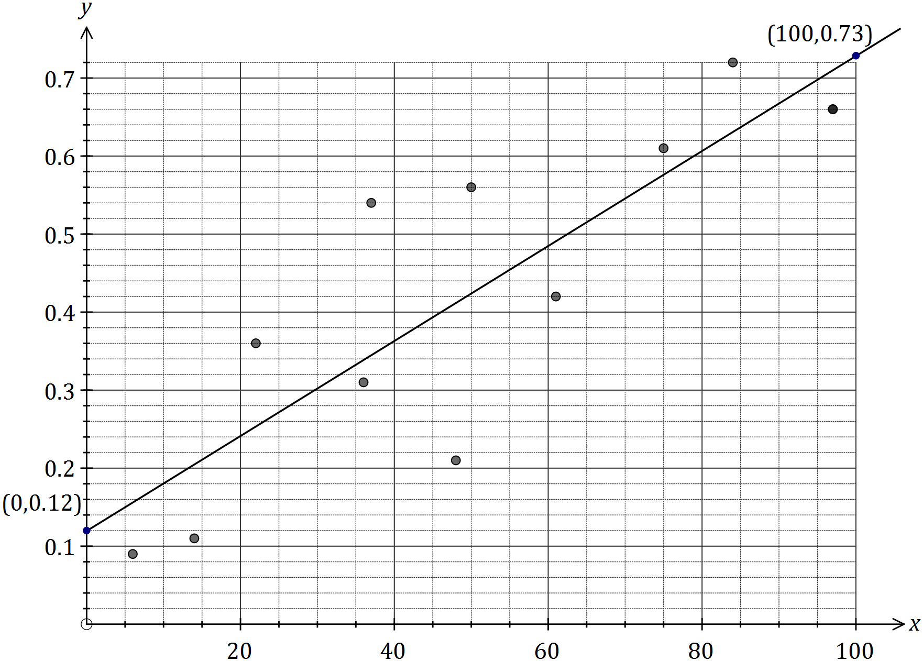

(a) Calculate the correlation coefficient for the data, and comment on how its value is reflected in the scatterplot above. (3 marks)

|  |
| --- |
| **Solution** |
| $r=0.86$ Strong positive value is reflected in increasing trend shown by points. |
| **Specific behaviours** |
| ✓ value that rounds to 0.86  ✓ ✓indicates direction and association |

(b) What percentage of the variation in the yield can be explained by the variation in the rainfall? (2 marks)

|  |
| --- |
| **Solution** |
| $r^{2}=0.735$ Approximately 74%. |
| **Specific behaviours** |
| ✓ indicates use of coefficient of determination  ✓ states correct percentage |

(c) Determine the equation for the least-squares line that models the data. (2 marks)

|  |
| --- |
| **Solution** |
| $$y=0.00609x+0.119$$ |
| **Specific behaviours** |
| ✓ gradient  ✓ -intercept |

(d) Draw the least-squares line on the scatterplot by first calculating two points that lie on the line. Clearly indicate these points. (3 marks)

|  |
| --- |
| **Solution** |
| Examples: (0, 0.12) and (100, 0.73)  See graph for line. |
| **Specific behaviours** |
| ✓ clearly shows two points that are not close together  ✓ line through calculated points  ✓ correct line, very close to (0, 0.12) and (100, 0.73) |

(e) Estimate the cucumber yield in a season that has 64 mm of rainfall and comment on the reliability of this value. (3 marks)

|  |
| --- |
| **Solution** |
| $y=0.00609\left(64\right)+0.119=0.51 \text{kg}$ Estimate is reliable as correlation is strong and involves interpolation. |
| **Specific behaviours** |
| ✓ value that rounds to 0.51  ✓ considers correlation  ✓ considers interpolation |

Question 10 (8 marks)

A high school for Years 7 – 12 has been built in a newly established housing development and opened

on 1st January 2016. The expected annual Year 7 student population is based on the following:



**(a)** The Principal of the school was only expecting a beginning population of 160.

How many more students were enrolled? (1 mark)

|  |
| --- |
| **Solution** |
| 240 students |
| **Specific behaviours** |
| ✓ states solution |

**(b)** Determine the annual percentage growth rate of the Year 7 student population. (1 mark)

|  |
| --- |
| **Solution** |
| 1.5% students |
| **Specific behaviours** |
| ✓ states solution |

**(c)** Given no students leave throughout the year, determine the year 7 population

at the end of each year for the first three years of the school’s operation. (3 marks)

|  |
| --- |
| **Solution** |
| End of year one: 240  End of year two: 243  End of year three: 247 |
| **Specific behaviours** |
| ✓✓✓ states all three solutions  ✓✓ If use 243, 247 and 251  ✓ If only one correct |

**(d)**

|  |
| --- |
| **Solution** |
| Calculates 288  Year 2029 |
| **Specific behaviours** |
| ✓ Calculates 288  ✓ States 2029 |

**(e)** ✓ States year 2020

Question 11 (7 marks)

The value of a machine used in a factory is recorded at the start of each year.

|  |  |  |  |
| --- | --- | --- | --- |
| Year | 2014 | 2015 | 2016 |
| Value of machine ($) | 6 875 | 5 500 | 4 400 |

(a) Explain why the three values in the table form a geometric sequence. (2 marks)

|  |
| --- |
| **Solution** |
| $$\frac{5500}{6875}=0.8,\frac{4400}{5500}=0.8$$ $$\text{Hence geometric, as constant ratio of terms}$$ |
| **Specific behaviours** |
| ✓ shows both pairs of terms have same ratio  ✓ explains nature of geometric sequence |

(b) What is the annual percentage rate of depreciation of the machine? (1 mark)

|  |
| --- |
| **Solution** |
| 20% |
| **Specific behaviours** |
| ✓ rate as percentage |

Assume that the machine continues to depreciate at the same rate.

(c) Determine a rule for $V_{n}$, the value of the machine $n$ years after 2014. (2 marks)

|  |
| --- |
| **Solution** |
| $$V_{n}=6875{\left(0.8\right)}^{n}$$ |
| **Specific behaviours** |
| ✓ uses th term form  ✓ uses correct coefficients |

(d) The machine will be replaced when its value at the start of the year falls below $500. Determine which year this will be. (2 marks)

|  |
| --- |
| **Solution** |
| Using n = 12 $$V_{12}=6875{\left(0.8\right)}^{12}=\$472$$ Year is 2026 |
| **Specific behaviours** |
| ✓ substitutes correct value of  ✓ states year |

Question 12 (11 marks)

In a recent study of artists who asked for a piece of their work to be included in an exhibition, each artist was classified by the variables (i) the state they worked in and (ii) whether their piece of work was accepted by the judges.

The table below shows the number of artists in each category.

|  |  |  |  |  |  |  |
| --- | --- | --- | --- | --- | --- | --- |
|  | State | NSW | VIC | QLD | WA | Total |
| Work accepted? | Yes | 8 | 27 | 21 | 8 | 64 |
| No | 108 | 86 | 143 | 39 | 376 |
|  | Total | 116 | 113 | 164 | 47 | 440 |

(a) Complete the missing values and totals in the table above. (4 marks)

|  |
| --- |
| **Solution** |
| See table |
| **Specific behaviours** |
| ✓ QLD Yes, ✓ Total No, ✓ NSW No, ✓ Totals |

(b) To identify the presence of an association between these two variables, explain why the state the artist worked in should be used as the explanatory variable. (2 marks)

|  |
| --- |
| **Solution** |
| It is possible for the 'state' to affect 'having work accepted', but not possible for 'having work accepted' to affect 'state artist works in'. Hence 'state' is explanatory variable and 'work accepted' is response variable. |
| **Specific behaviours** |
| ✓ reasonable argument using just explanatory variable  ✓ discussion using both explanatory and response variables |

(c) Rounding percentages to the nearest whole number, complete the percentaged two-way table below so that it may be used to identify the presence of an association between the categorical variables. (3 marks)

|  |  |  |  |  |  |
| --- | --- | --- | --- | --- | --- |
|  | State | NSW | VIC | QLD | WA |
| Work accepted? | Yes | 7% | 24% | 13% | 17% |
| No | 93% | 76% | 87% | 83% |

|  |
| --- |
| **Solution** |
| See table |
| **Specific behaviours** |
| ✓ NSW Yes  ✓ one column correct  ✓ all columns correct |

(d) Comment on the presence of an association between the two variables. (2 marks)

|  |
| --- |
| **Solution** |
| An association clearly exists, as artists from VIC (24%) are much more likely to have their work chosen than an artist from NSW (7%), QLD (13%) or WA (17%). |
| **Specific behaviours** |
| ✓ states association exists  ✓ explains reasoning |

Question 13 (5 marks)

Louisa borrows an amount of money to purchase her first car with repayments that she can easily afford. The following equation shows the amount she borrowed and her monthly repayments.



**(a)** Determine the following:

**(i)** The amount of the loan. (1 mark)

|  |
| --- |
| **Solution** |
| 8500 |
| **Specific behaviours** |
| ✓ States solution |

**(ii)** The annual interest rate. (1 mark)

|  |
| --- |
| **Solution** |
| 9.66% |
| **Specific behaviours** |
| ✓ States solution |

**(iii)** The amount she has paid in the first 6 months of the loan (1 mark)

|  |
| --- |
| **Solution** |
| $1350 |
| **Specific behaviours** |
| ✓ States solution |

**(b)** Determine how many years and months it will take for Louisa to pay off the loan. (1 mark)

|  |
| --- |
| **Solution** |
| 3 years 10 months |
| **Specific behaviours** |
| ✓ States solution |

**(c)** Determine the amount of interest Louisa will pay over the period of the loan. (1 marks)

|  |
| --- |
| **Solution** |
| $1674.70 |
| **Specific behaviours** |
| ✓ States solution |

Question 14 (6 marks)

A student was trying to decide whether fitting a linear model to their data was an appropriate choice. They calculated the least-squares line through the 30 points to be $\hat{y}=2.4x-12.5$ and the correlation coefficient $r=0.98$.

(a) Explain why constructing a residual plot would help the student decide. (2 marks)

|  |
| --- |
| **Solution** |
| The residual plot will enable the student to see if any general pattern is evident in the residuals - if there is, the model will not be appropriate, but otherwise model is usually valid. |
| **Specific behaviours** |
| ✓ indicates looking for pattern in residuals  ✓ explains outcomes associated with pattern |

The residual plot for the student's data is shown below.

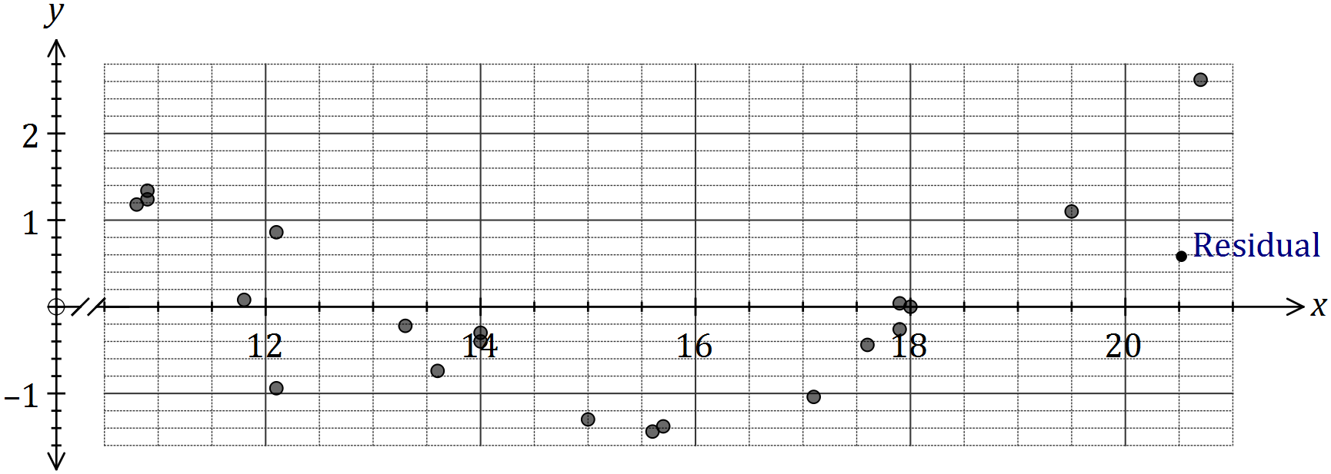

(b) One residual is missing from the plot, corresponding to the original data point $(20.5, 37.3)$.

Calculate the residual for this point and add it to the residual plot. (3 marks)

|  |
| --- |
| **Solution** |
| $$\hat{y}=2.4\left(20.5\right)-12.5=36.7$$ $$\text{Residual}=37.3-36.7=0.6$$ |
| **Specific behaviours** |
| ✓ calculates  ✓ calculates residual  ✓ plots point |

(c) What conclusion should the student draw about the appropriateness of the linear model?

(1 mark)

|  |
| --- |
| **Solution** |
| Pattern evident so linear model not appropriate. |
| **Specific behaviours** |
| ✓ states not appropriate |

Question 15 (8 marks)

Jay has $7000 that he wants to invest for a period of time without touching it.

1. If he chooses to invest this money in an account earning compound interest at the rate of 4.5% per annum, determine the:
   1. value of his investment after four years, if interest is paid annually. (1 mark)

|  |
| --- |
| **Solution** |
| $8347.63 |
| **Specific behaviours** |
| ✓ States solution |

* 1. time required for him to double his investment, if interest is paid monthly. (2 marks)

|  |
| --- |
| **Solution** |
| $$14000={7000(1+\frac{0.045}{12})}^{12x}$$ 186 months OR  15 years and 6 months |
| **Specific behaviours** |
| ✓shows equation to solve  ✓ States either solution |

Jay is currently deciding between two options and wishes to compare them.

Option A: Invest the $7000 in an account earning compound interest at the rate of 3.5% per annum, with interest paid monthly.

Option B: Invest the $7000 in an account earning compound interest at the rate of 3.3% per annum, with interest paid daily.

1. Calculate the effective annual rate of interest for Options A and B, correct to two decimal places, and hence decide on the better option for Jay. (5 marks)

|  |
| --- |
| **Solution** |
| Option A effective interest rate: 3.56%  Option B effective interest rate: 3.35% |
| **Specific behaviours** |
| ✓✓Calculate option A  ✓✓Calculate option B  -1 for rounding errors’  ✓States Option A is a better option |

Question 16 (9 marks)

Following the analysis of data collected from a group of women aged between 22 and 38, a strong, linear relationship between their age ($x$, in years) and percentage chance of conception ($y$, percent) in any given month was observed. The coefficient of determination between the variables was 0.87 and the equation of the least-squares line was $\hat{y}=-0.88x+45.8$.

(a) Determine the correlation coefficient between $x$ and $y$. (2 marks)

|  |
| --- |
| **Solution** |
| $$r^{2}=0.87⇒r=±\sqrt{0.87}≈±0.93$$ $$\text{As slope negative, then} r=-0.93$$ |
| **Specific behaviours** |
| ✓ determines value  ✓ determines sign |

(b) Estimate the monthly percentage chance of conception of a woman aged

(i) 18 years. (1 mark)

|  |
| --- |
| **Solution** |
| $$\hat{y}=30\%$$ |
| **Specific behaviours** |
| ✓ states value |

(ii) 35 years. (1 mark)

|  |
| --- |
| **Solution** |
| $$\hat{y}=15\%$$ |
| **Specific behaviours** |
| ✓ states value |

(c) Comment, with reasoning, on the reliability of each of your estimates in (b). (3 marks)

|  |
| --- |
| **Solution** |
| (i) is unreliable, as involves extrapolation.  (ii) is reliable, as interpolation and correlation is strong. |
| **Specific behaviours** |
| ✓ indicates (i) unreliable (ii) reliable  ✓ reason for (i)  ✓ reason for (ii) |

(d) Describe the meaning of the slope of the least-squares lines in the context of this question. (2 marks)

|  |
| --- |
| **Solution** |
| For each year a woman in the group ages, so their percentage chance of conception decreases by 0.88%. |
| **Specific behaviours** |
| ✓ indicates as age increases, % chance decreases  ✓ quantifies change with units |

Question 17 (12 marks)

As part of a trial to reintroduce woylies (an endangered species of mammals) to a wildlife reserve, researchers modelled the expected size of a woylie population, $P_{n}$, using the rule below where $n$ is the number of months since the trial began.

$$P_{n+1}=0.85P_{n}+30, P_{0}=20.$$

(a) State

(i) The size of the woylie population at the start of the trial. (1 mark)

|  |
| --- |
| **Solution** |
| 20 Woylies |
| **Specific behaviours** |
| ✓ states solution |

(ii) The number of woylies added to the reserve each month. (1 mark)

|  |
| --- |
| **Solution** |
| 30 Woylies |
| **Specific behaviours** |
| ✓ states solution |

(iii) The percentage loss of existing woylies in the reserve each month. (1 mark)

|  |
| --- |
| **Solution** |
| 15% loss |
| **Specific behaviours** |
| ✓ states solution |

(b) Complete the missing values in the table below to show the expected number of woylies over the first six months. (2 marks)

|  |  |  |  |  |  |  |  |
| --- | --- | --- | --- | --- | --- | --- | --- |
| $$n$$ | 0 | 1 | 2 | 3 | 4 | 5 | 6 |
| $$P_{n}$$ | **20** | **47** | 70 | 89 | 106 | **120** | **132** |

|  |
| --- |
| **Solution** |
| See table |
| **Specific behaviours** |
| ✓ Calculates for n = 0,1  ✓ Calculates for n = 5,6 |

(c) Determine the expected size of the woylie population after three years. (2 marks)

|  |
| --- |
| **Solution** |
| n = 36  Population size 199 (rounded down) |
| **Specific behaviours** |
| ✓ ✓States solution  ✓ If answers 200.  ✓ If unrounded solution |

(d) Graph the population of woylies on the axes below for $0≤n≤12$. (3 marks)

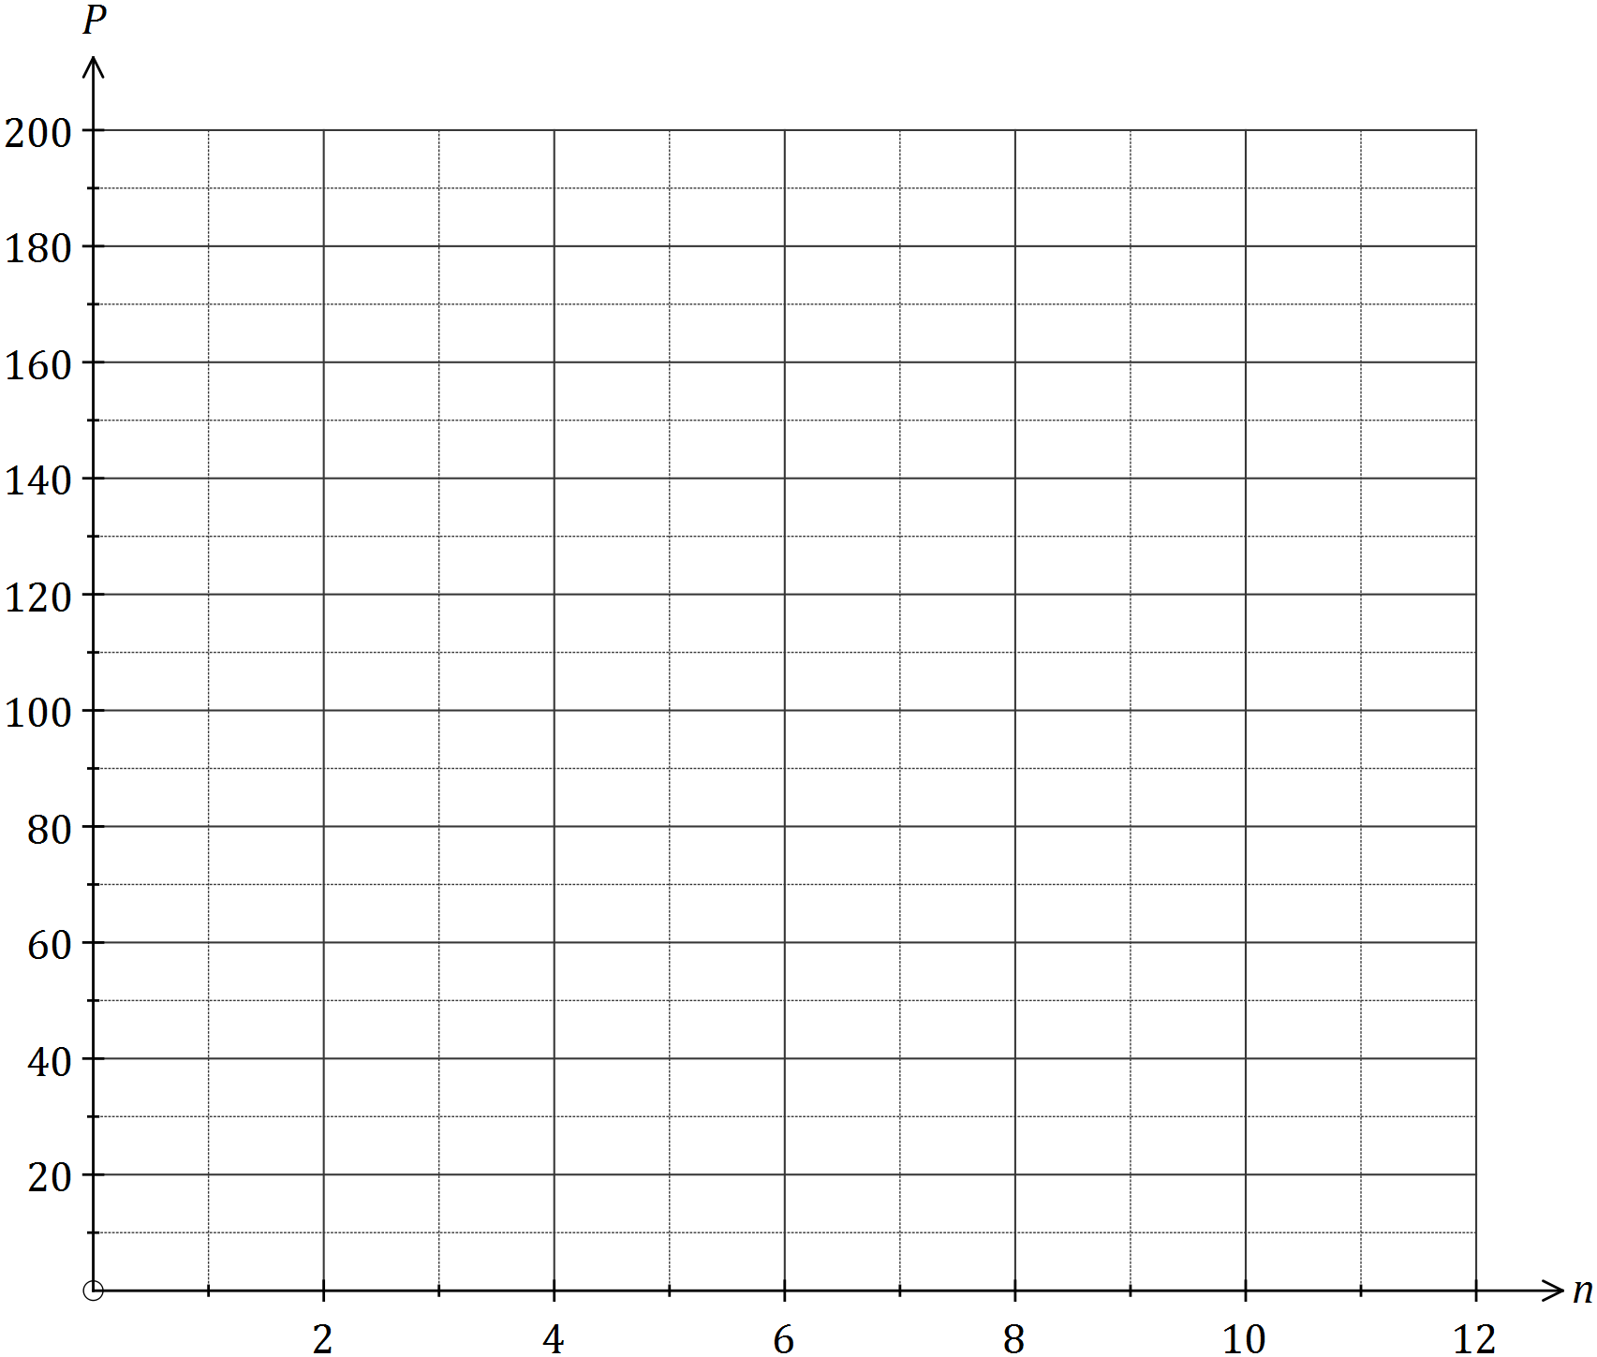

|  |
| --- |
| **Solution** |
| See diagram |
| **Specific behaviours** |
| ✓✓ All points corrected plotted  ✓ connects with a smooth line |

(e) Use the model to describe how the size of the woylie population in the reserve will change over the first three years. (2 marks)

|  |
| --- |
| **Solution** |
| “Long term steady state of 200 is achieved” |
| **Specific behaviours** |
| ✓✓ States “steady state”  ✓ States “Increasing at a reducing amount” |

Question 18 (13 marks)

1. Jim is about to retire and is planning to take an annuity from his pension fund. He sets up the pension fund on his 70th birthday with $700 000 and he estimates the fund can generate a growth rate of 5% per year. He plans to start withdrawing an annuity of $45 000 starting on his following birthday.

|  |
| --- |
| **Solution** |
| $$T_{n+1}=1.05T_{n}-45000 ; T_{0}=700 000$$ |
| **Specific behaviours** |
| ✓States  ✓States - 45000  ✓States |

* 1. Write a recurrence relation to calculate the total amount in the fund directly after each withdrawal. (3 marks)

* 1. For how many years will Jim be able to receive his annuity of $45 000? (2 marks)

|  |
| --- |
| **Solution** |
| 30 years |
| **Specific behaviours** |
| ✓✓States Solution |

* 1. Assuming that all other conditions are the same, explain what would happen if Jim decided to withdraw $35 000 per year instead of $45 000 per year. (2 marks)

|  |
| --- |
| **Solution** |
| Example of perpetuity |
| **Specific behaviours** |
| ✓✓ States “perpetuity” or something similar |

1. Victoria sets up her pension fund on July 1 2016 with a principal of $750 000. The fund guarantees an annual growth rate of 5.5% compounded monthly and she plans to take an annuity of $55 000 each year on July 1, starting in 2017.

|  |
| --- |
| **Solution** |
| $$T_{n+1}={T_{n}(1+\frac{0.055}{12})}^{12}-55000 ; T_{0}=750 000$$ 2025 = $T_{9}$ = $606 278.65 |
| **Specific behaviours** |
| ✓Uses effective interest rate  ✓States solution |

* 1. Calculate the balance in the fund after the annuity is withdrawn in July 2025.   
      (2 marks)

The investment fund revised its annual interest rate to 7% compounded monthly on July 1 2025 guaranteed for the period to July 2030 and Victoria continued withdrawing $55 000 as usual.

|  |
| --- |
| **Solution** |
| $$T_{n+1}={T_{n}(1+\frac{0.07}{12})}^{12}-55000 ; T_{0}=606 245.43$$ 2030 = $T_{5}$ = $541 736.77 |
| **Specific behaviours** |
| ✓Uses effective interest rate  ✓States solution |

* 1. Calculate the balance in the fund after a withdrawal is made on July 1 2030.   
      (2 marks)

* 1. Calculate, to the nearest $100, the maximum amount Victoria could withdraw annually, starting in 2025, without decreasing her balance. (2 marks)

|  |
| --- |
| **Solution** |
| $$606 245.43\left(\frac{7.229}{100}\right)$$ =$43 827.88  Nearest $100 without reducing $43 800 |
| **Specific behaviours** |
| ✓Uses effective interest rate  ✓States solution correct to nearest $100 |